**Remarks** :

1. This Memorandum of Understanding is a broad-based partnership for a framework of implementation only.

2. If any project is to be undertaken within the duration of the MOU, all the details of the project must be determined in the form of the MOU/MOA.

**Memorandum of Understanding**

**LOGO**

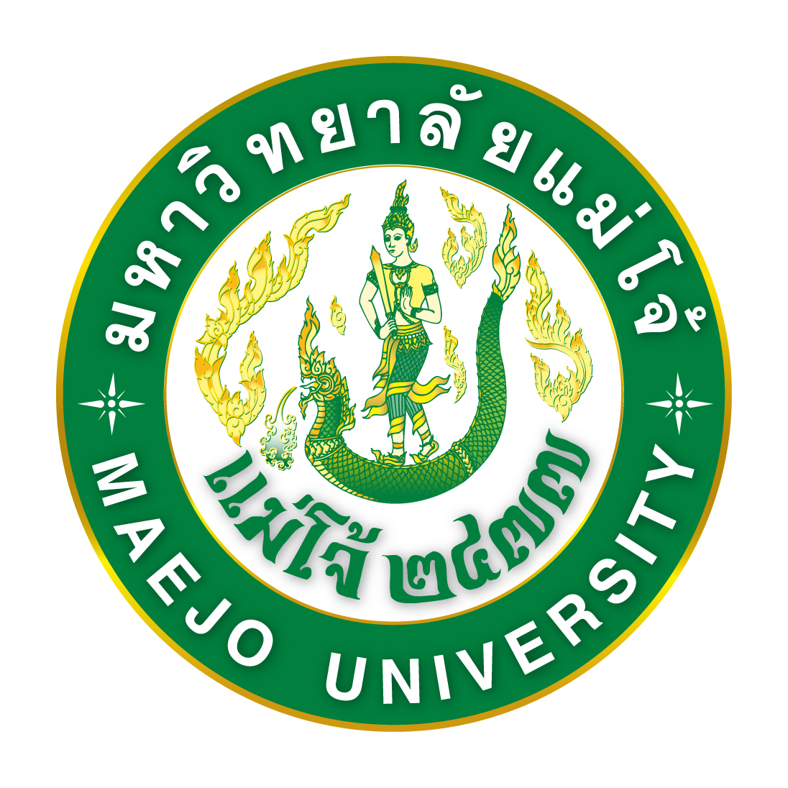

**Project.......................**

**between**

**Maejo University** **(Faculty...........)**

**and**

**(……………Name of the University/Organization…………….)**

This Memorandum of Understanding is made at ............................ dated on ................ between Maejo University, a University established and existing under the laws of Thailand, and having its principal office at No. 63, Moo 4, Nongharn Sub-district (Tambon), Sansai District (Amphoe) in Chiang Mai, Thailand (hereinafter referred to as “MJU”) by ...............(Full Name of the Person in Charge and his/her position)...............

and ..............(Name of the University/Organization)................ and having its principal office at No.............. Street ..................... Sub-district .................. District....................... Province............................... Country…………………….. (hereinafter referred to as “……….”) by ...............(Full Name of the Person in Charge and his/her position)............... *(In the case of the company, the company must specify a company certificate with a letter of power of attorney (if any))*

*(In this part, explain the background of this Memorandum of Understanding....)*

**WHEREAS:**

MJU and .......... are desirous to collaborate on .........(Name of the Project)...... (hereinafter referred to as “Project”), on the terms and conditions as specified hereunder:

**1. Objectives and Scope of Cooperation**

(The scope of cooperation shall be subject to Section 2.1 of the Maejo University Announcement Re: Criteria for Consideration of Cooperation on Hemp / Cannabis Research and Development.)

**2. Duties and Responsibilities**

2.1 Duties and Responsibilities of MJU

2.1.1 MJU will support the knowledge, researchers, and the place to implement the project.

2.1.2 …………..

2.2 Duties and Responsibilities of …….

2.2.1 Provide the budget as well as necessary equipment in the project without charge or any other benefit from MJU.

2.2.2 Process various licenses related to the project on behalf of Maejo University, and pay the cost of doing all such actions.

2.2.3 The company agrees to hand over all the assets such as buildings, durable articles, and equipment produced or have been used in all projects for MJU upon the completion of the sub-project under this Memorandum of Understanding.

2.2.4 ………………………………………………………………………………..

**3.** All rights in the knowledge and intellectual property that arise from the implementation of the research project are the joint rights of both parties. In respect of the benefit-sharing as well as the intellectual property rights holdings, they shall be specifically agreed in the MOU of each project.

**4.** MJU reserves the rights to provide news or publicize about the project. (Name of the University/Organization) can do so only after having written permission from MJU.

**5.** In order to achieve this MOU, both parties will jointly appoint a working group and well-rounded researchers to join in the development of the project and will assign a representative of each party to agree in details within the objectives and scope of the cooperation and the duties and responsibilities of the partners set forth in Articles 1 to 4 aforementioned. The assignments for the representative of each party shall be written as a memorandum of agreement and be signed by the competent authorities of both parties.

**6.** The agreement is established for an initial period of 5 (five) years from the date signed below and is subjected to review prior to a potential date of renewal.

**7.** This agreement can be revised or amended with approval from both parties. The party who wishes to make amendments must notify the other party at least 30 (thirty) days in advance. The agreed amendments shall be provided as an attached MOU.

**8.** Cancellation of this MOU prior to the end of the agreement’s pursuant stated in article 6 is possible. The party wishing to cancel must notify another party not less than 30 (thirty) days in advance by sending a written intention letter. The cancellation of the memorandum of understanding will take effect only when both parties agree together (including any agreements attached to this memorandum of understanding). The termination of the memorandum of understanding will not affect binding or ongoing cooperation.

**9.** This agreement aims to set a framework for cooperation between each other, neither party intended to have any legal obligations.

This MOU is made in 2 (two) copies of the same text. Each party has read and understood the message throughout completely and agrees that the intents are correct in all respects. Both parties will sign the MOU along with their seals (if any) as important pieces of evidence in the presence of witnesses. Each party keeps 1 (one) copy of the signed MOU.

**Maejo University**   **(Name of the University/Organization)**

(Sign) (Sign)

( ) ( )

Position ...................................... Position .............................................

(Sign) Witness 1 (Sign) Witness 2

( ) ( )

Position ...................................... Position .............................................